**EXERCISE 05**

*01) Find the ASCII values of the masters’ names.*

SELECT name, ASCII (name) AS ascii_value

FROM master;

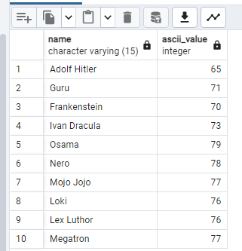

*02)Append the country names in front of the minion names.*

SELECT CONCAT(nationality, ' ', name) AS full_name

FROM minion;

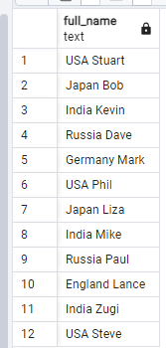

*03)Ceil the currency values which start with a consonant and*  *floor the others.*

SELECT

name,

CASE

WHEN name ~ '^[^aeiouAEIOU]' THEN ceil(b_currency)

ELSE FLOOR(b_currency)

END AS adjusted_value

FROM currency;

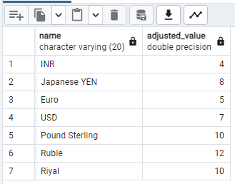

*04) Repeat the string ‘ba’ a dozen number of times.*

SELECT REPEAT('ba', 12) AS repeated_string;

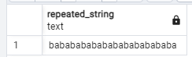

*05) Reverse the names of all the minions.*

SELECT name, REVERSE(name) AS reversed_name

FROM minion;

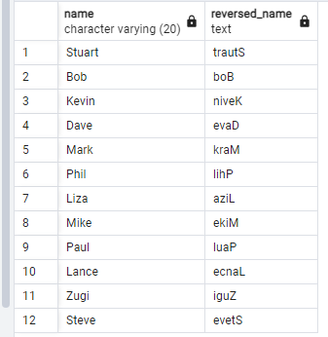

*06) Convert all the country names to uppercase.*

SELECT country,

UPPER(country) AS uppercase_name

FROM mission;

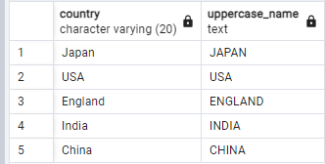

*07) Display the current time.*

SELECT NOW() AS current_time;

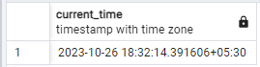

*08) Find the minion with least salary*

SELECT name, hiring_charge

FROM minion

ORDER BY hiring_charge ASC

LIMIT 1;

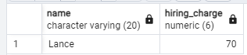

*09)* *How long (in weeks) was the mission 504*

SELECT mission_id,

(to_date - from_date) / 7 AS duration_in_weeks

FROM mission

WHERE mission_id = 504;

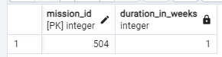

*10)* *Display the duration of all training offered.*

SELECT training_id,

(to_date - from_date) AS duration

FROM training;

